Bài 1:

5 Trang web có responsive

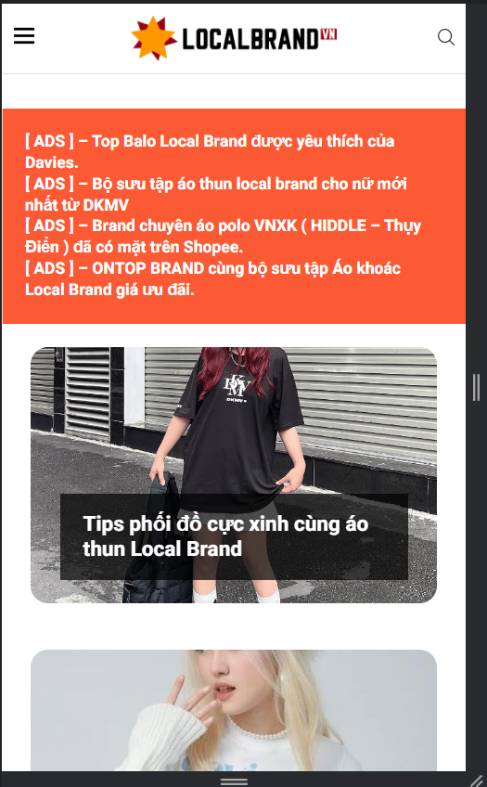 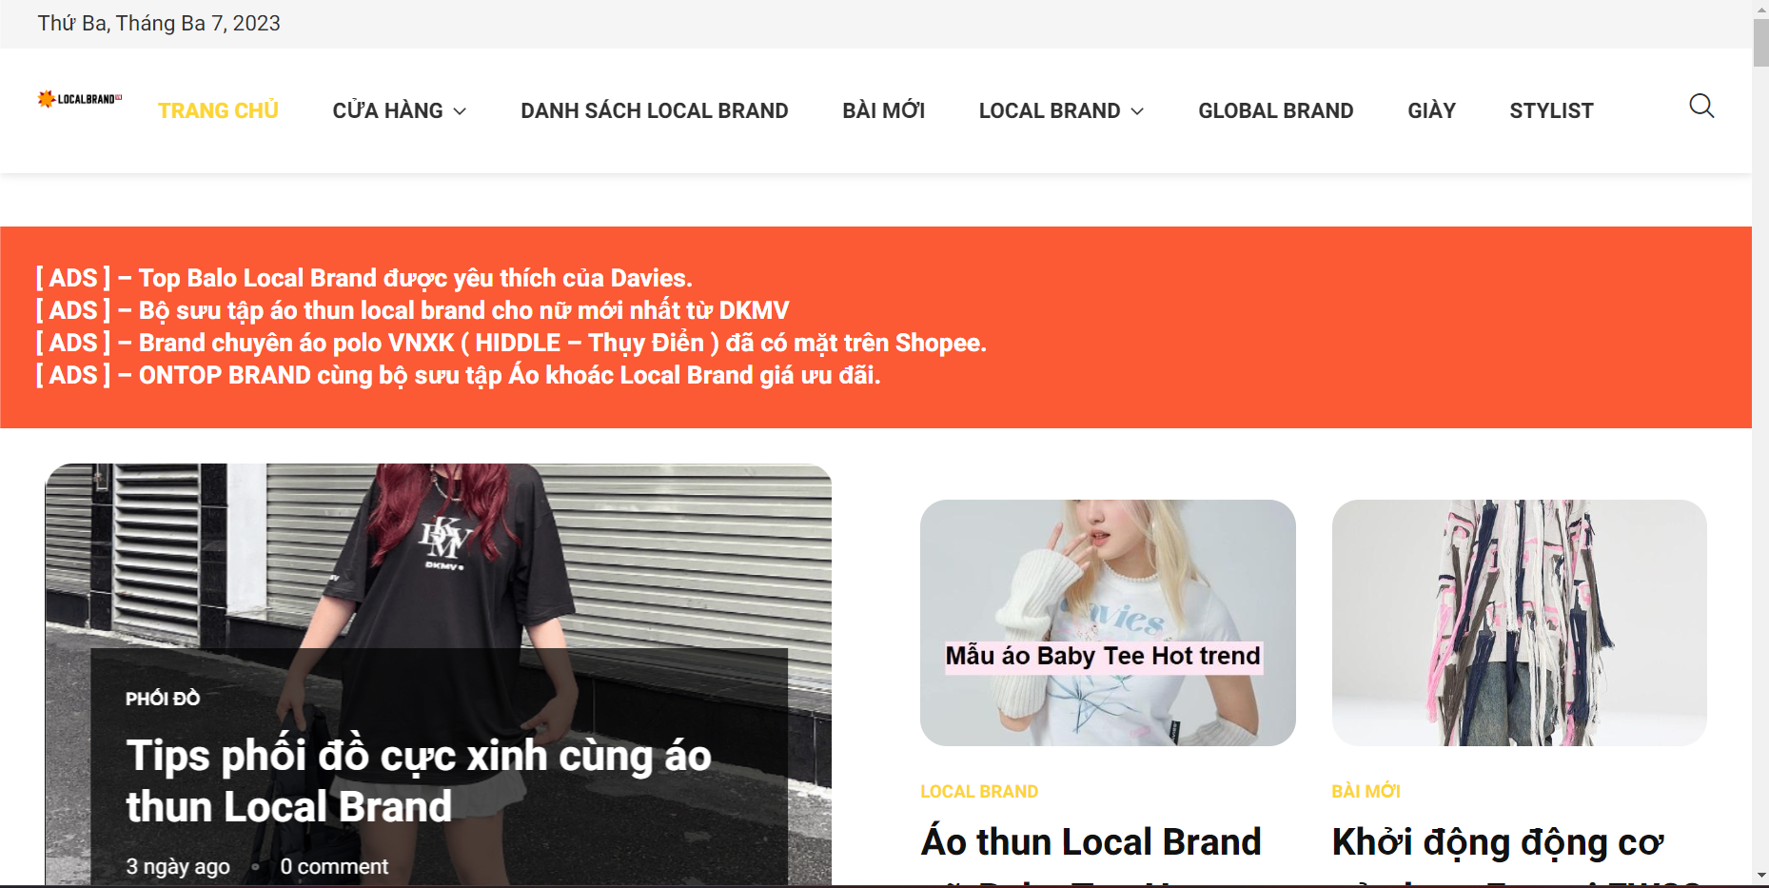

+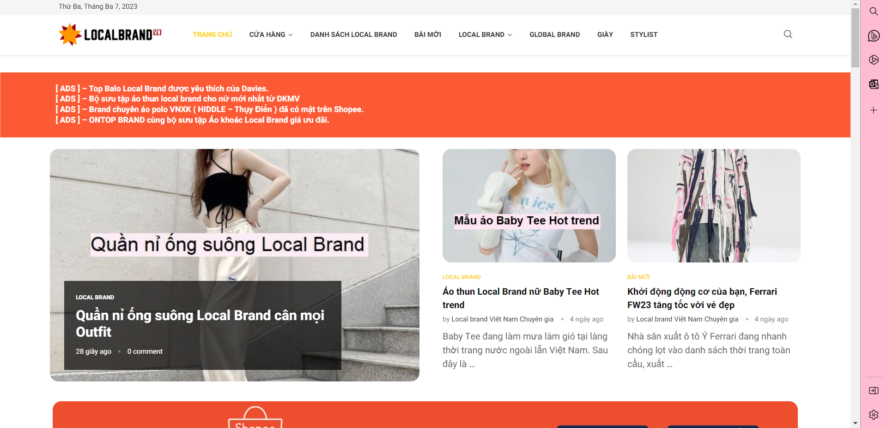

Link: [BACKPACKS - RAINBUSHOP](https://rainbushop.vn/collections/backpacks)

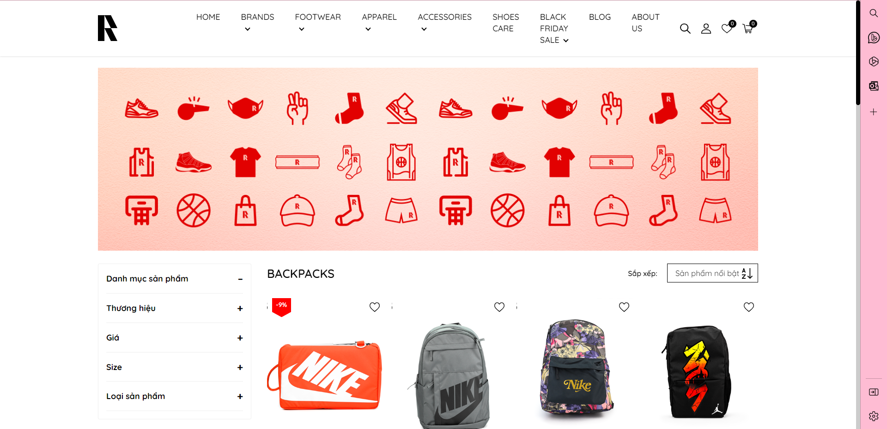

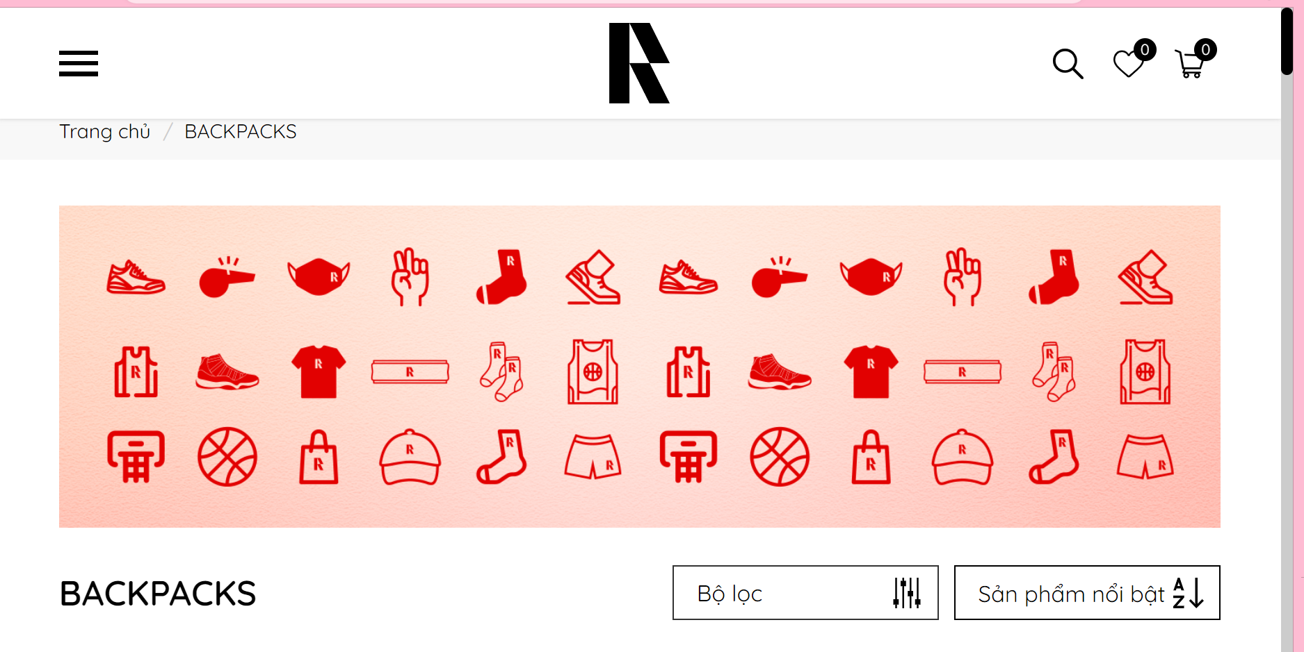

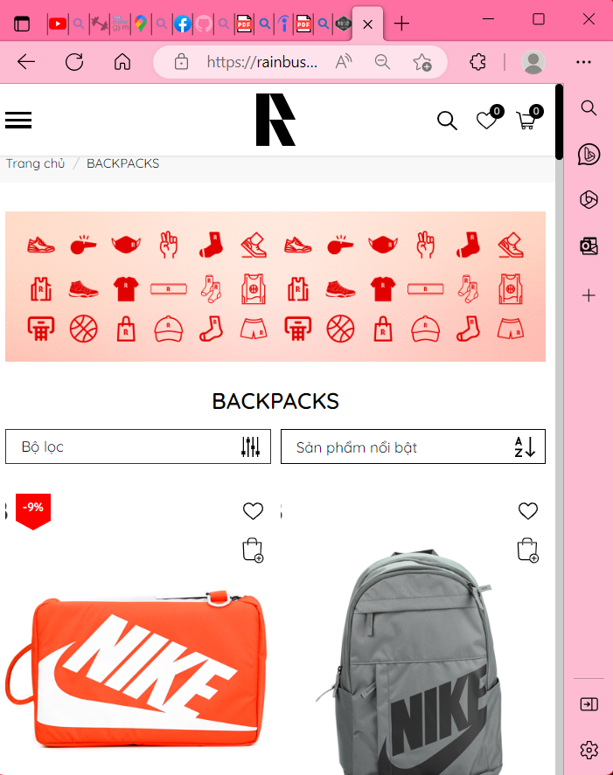

Link: [Nike. Just Do It. Nike VN](https://www.nike.com/vn/)

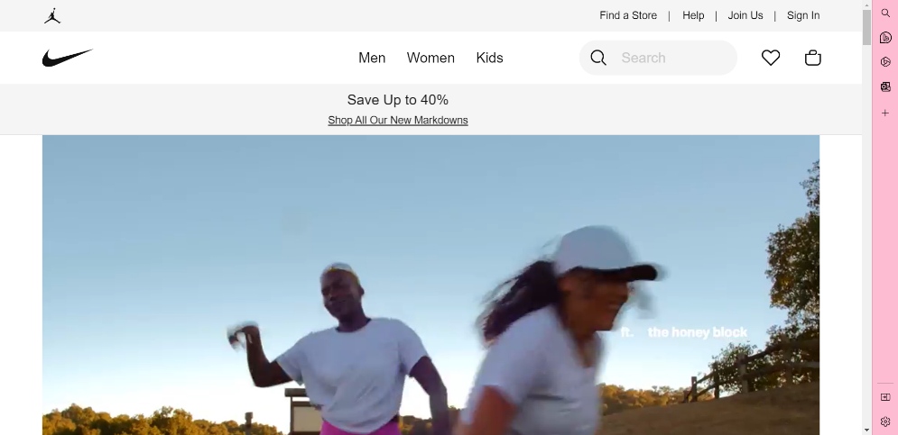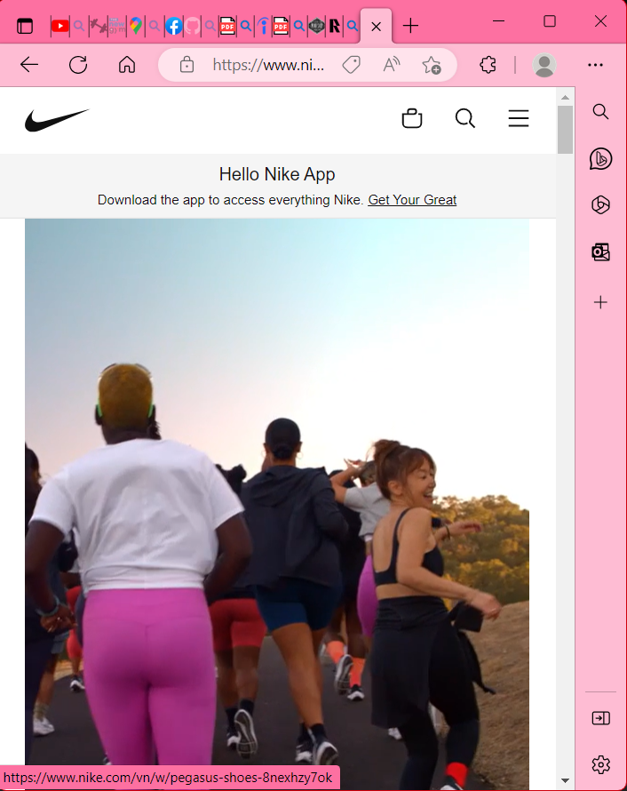

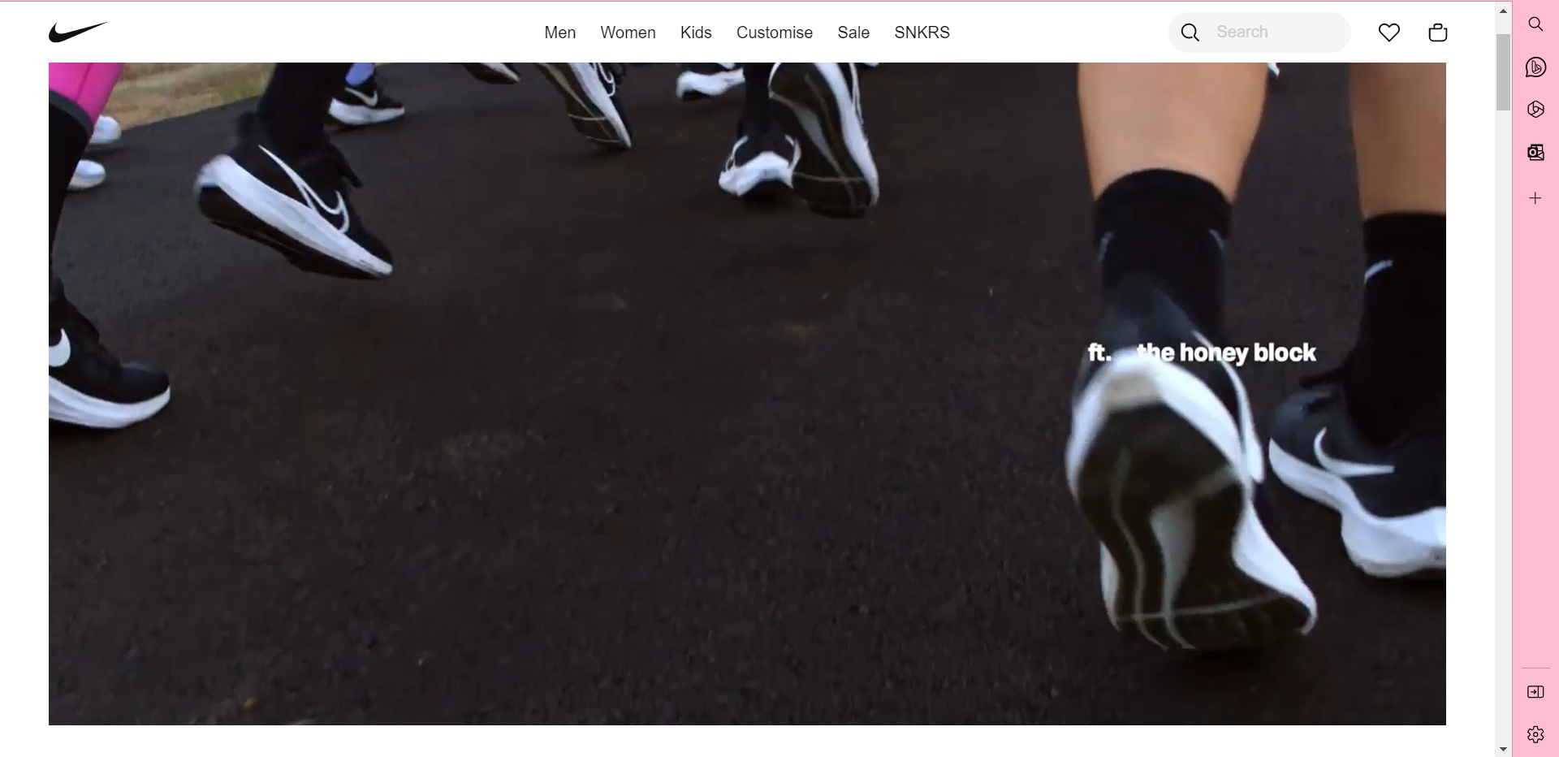

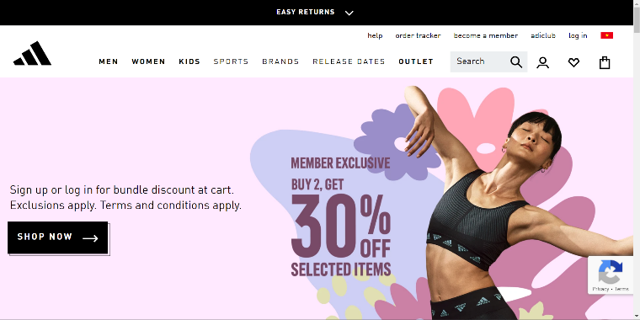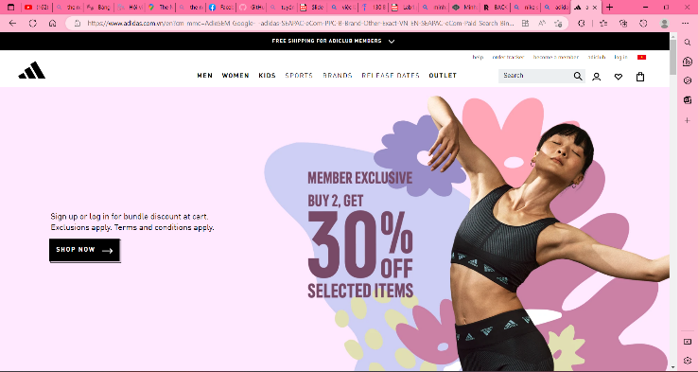Link: [adidas Official Website | adidas Vietnam](https://www.adidas.com.vn/en?cm_mmc=AdieSEM_Google-_-adidas-SEAPAC-eCom-PPC-B-Brand-Other-Exact-VN_EN-SEAPAC-eCom-Paid_Search_Bing-_-B-Other-Exact-EN-_-adidas-_-dv%3AeCom&cm_mmc1=VN&cm_mmc2=e&gclid=33625e8f452712f39d5f3a8a1bf65e31&gclsrc=3p.ds)

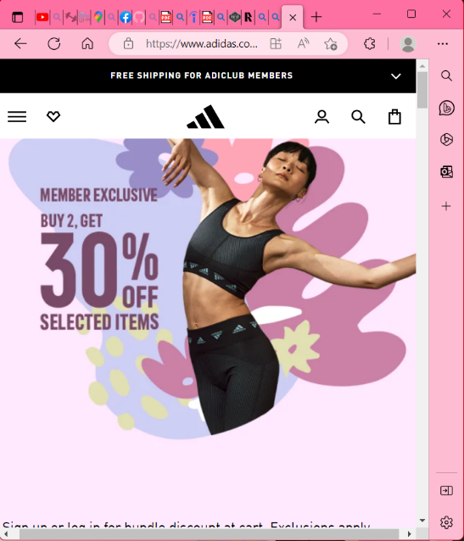

Link: [Sản Phẩm – Ananas](https://ananas.vn/product-list/?gender=men&category=&attribute=track-6)

